**Web Designing Assignment**

**Term-1**

**Module (HTML) -1**

**Que .1 Are the HTML tags and elements the same thing?**

**Ans.** HTML tags are used to hold the HTML element. HTML element holds the content. HTML attributes are used to describe the characteristic of an HTML element in detail. Whatever written within a HTML tag are HTML elements.

**Example.**

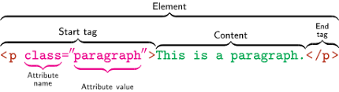

**Que.2 What are tags and attributes in HTML?**

**Ans.** HTML tags are used to hold the HTML element. HTML element holds the content. HTML attributes are used to describe the characteristic of an HTML element in detail. HTML tag starts with < and ends with > Whatever written within a HTML tag are HTML elements.

**Example.**

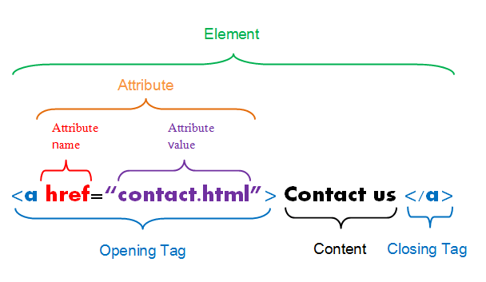

**Que.3 What are void elements in HTML? With Example.**

**Ans.** A void element is an element whose content model never allows it to have contents under any circumstances. Void elements can have attributes. The following is a complete list of the void elements in HTML : area , base , br , col , command , embed , hr , img , input , keygen , link , meta , param , source , track , wbr.

**Example.**

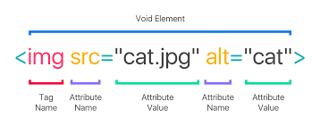

**Que.4 What are HTML Entities? With Example.**

**Ans.** An HTML entity is used to display invisible characters and reserved characters that would otherwise be interpreted as HTML code. It is a piece of text, or string, that begins with an ampersand ( & ) and ends with a semicolon ( ; ).

**Example.**

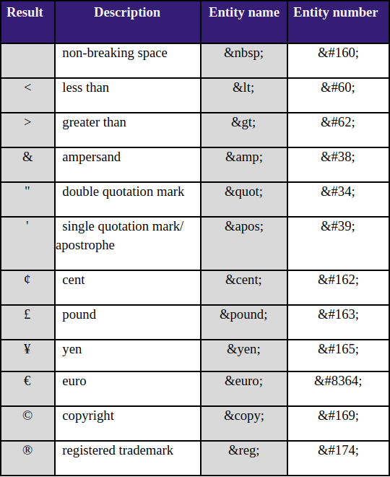

**Que.5 What are different types of lists in HTML? With Example.**

**Ans. There are three types of lists in HTML:**

Unordered list or Bulleted list (ul)

Ordered list or Numbered list (ol)

Description list or Definition list (dl)

**Example.**

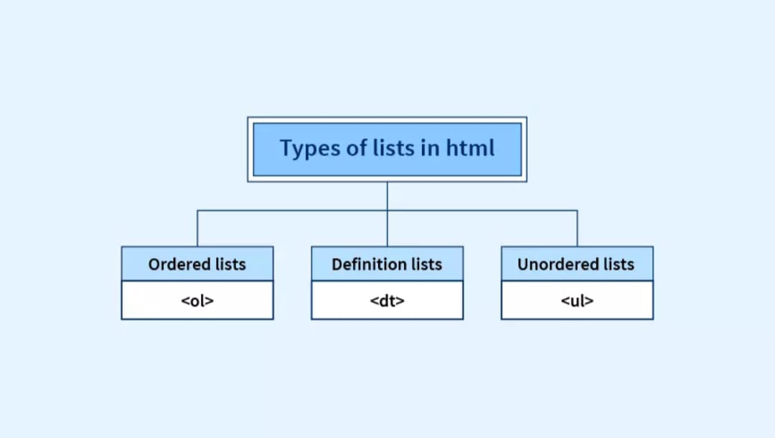

**Que.6 What is the ‘class’ attribute in HTML? With Example.**

**Ans.** The class attribute specifies one or more classnames for an element. The class attribute is mostly used to point to a class in a style sheet. However, it can also be used by a JavaScript (via the HTML DOM) to make changes to HTML elements with a specified class.

**Example.**

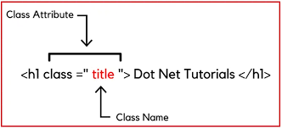

**Que.7 What is the difference between the ‘id’ attribute and the ‘class’ attribute of HTML elements? With Example.**

**Ans.** Remember the difference between Class and ID: A Class name can be used by multiple HTML elements, while an ID name must only be used by one HTML element within the page. The following is a sample HTML page using the Class name GreekCity. You can copy code from this to try it out yourself.

**Example.**

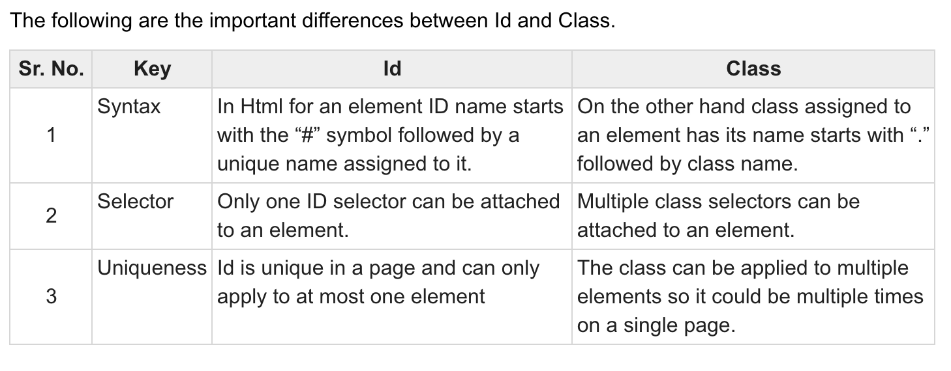

**Que.8 What are the various formatting tags in HTML?**

**Ans. Formatting elements were designed to display special types of text:**

* <b> Bold text.
* <strong> Important text.
* <i> Italic text.
* <em> Emphasized text.
* <mark> Marked text.
* <small> Smaller text.
* <del> Deleted text.
* <ins> Inserted text.

**Example.**

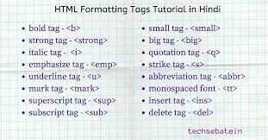

**Que.9 How is Cell Padding different from Cell Spacing? With Example.**

**Ans.** Cellpadding basically defines the space present between a table cell's border and the content present in it. Cellspacing basically defines the space present between individual adjacent cells. One can create it using the tag of HTML <table>, but it sets the type attribute to cellpadding.

**Example.**

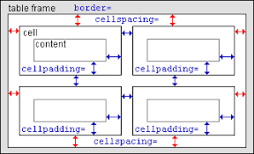

**Que.10 How can we club two or more rows or columns into a single row or column in an HTML table? With Example.**

**Ans.** It can be done by using the rowspan and colspan attribute in HTML. The rowspan is used to merge or combine the number of cells in a row whereas the colspan is used to merge column cells in a table.

**Example.**

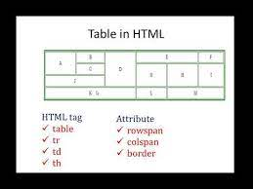

**Que.11 What is the difference between a block-level element and an inline element?**

**Ans.** Block Elements occupy the full width irrespective of their sufficiency. Inline elements don't start in a new line. Block elements always start in a line. Inline elements allow other inline elements to sit behind.

**Example.**

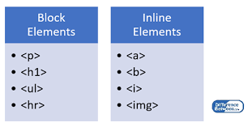

**Que.12 How to create a Hyperlink in HTML? With Example.**

**Ans.** To make a hyperlink in an HTML page, use the <a> and </a> tags, which are the tags used to define the links. The <a> tag indicates where the hyperlink starts and the </a> tag indicates where it ends. Whatever text gets added inside these tags, will work as a hyperlink. Add the URL for the link in the <a href=" ">.

**Example.**

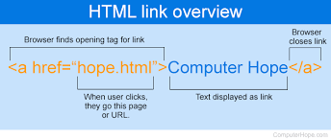

**Que.13 What is the use of an iframe tag? With Example.**

**Ans.** An inline frame (iframe) is a HTML element that loads another HTML page within the document. It essentially puts another webpage within the parent page. They are commonly used for advertisements, embedded videos, web analytics and interactive content.

**Example.**

 <iframe width="692" height="450" src="https://www.youtube.com/embed/Y9pgsPW-KIE?si=gklnxtuGqlot_-mA" title="YouTube video player" frameborder="0" allow="accelerometer; autoplay; clipboard-write; encrypted-media; gyroscope; picture-in-picture; web-share" allowfullscreen></iframe>

**Que.14 What is the use of a span tag? Explain with example?**

**Ans.** The <span> tag is an inline container used to mark up a part of a text, or a part of a document. The <span> tag is easily styled by CSS or manipulated with JavaScript using the class or id attribute. The <span> tag is much like the <div> element, but <div> is a block-level element and <span> is an inline element.

**Example.**

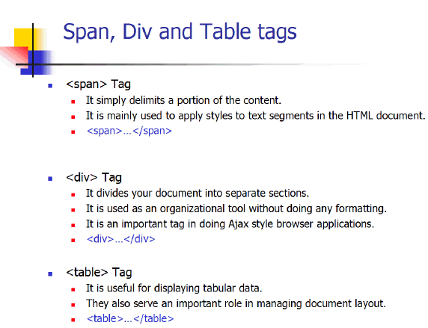

**Que.15 How to insert a picture into a background image of a web page? With Example.**

**Ans.** We can use the background attribute in the body tag to set an image as the background of the webpage. We will need to specify the URL or the location of the image which we want to set to the background attribute of the body tag.

**Example.**

**< style="background-image: url('example.jpg');">.**

<img src="Leaf 2.png" alt="" height="100px" width="100px">

**Que.16 How are active links different from normal links?**

**Ans.** In the above output, notice the visited link after going back from the home page. Active Link: In example 1, If you left or right-click any one of the links Visited or Unvisited, it will turn into Red and Underline. Active Links shows that the browser is in the process to load a new resource.

**Que.17 What are the different tags to separate sections of text?**

**Ans.**

**We separate a section of texts in HTML using the below tags:**

* <br> tag – It is used to separate the line of text. It breaks the current line and shifts the flow of the text to a new line.
* <p> tag–This tag is used to write a paragraph of text.
* <blockquote> tag–This tag is used to define large quoted sections.

**Example.**

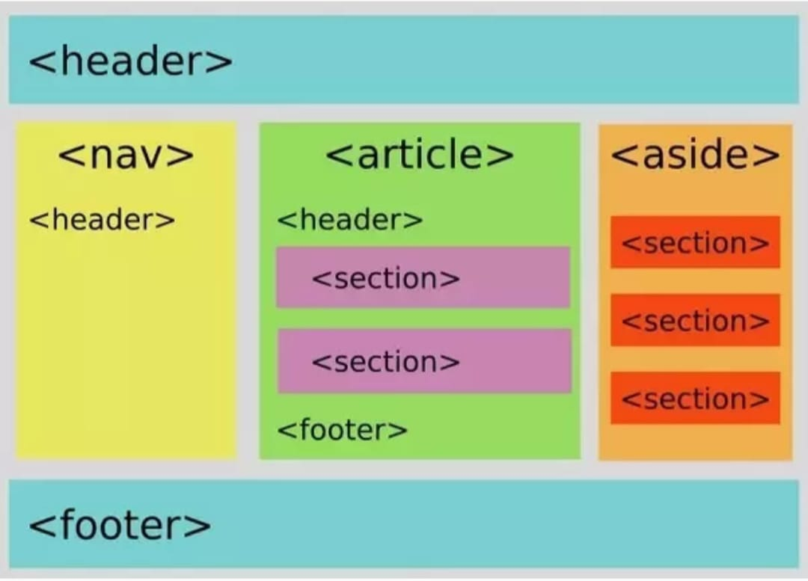

**Que.18 What is SVG?**

**Ans.**

* SVG stands for Scalable Vector Graphics
* SVG is used to define vector-based graphics for the Web
* SVG defines the graphics in XML format
* Every element and every attribute in SVG files can be animated
* SVG is a W3C recommendation
* SVG integrates with other W3C standards such as the DOM and XSL

**Que.19 What is difference between HTML and XHTML?**

**Ans.** The main difference between them is the syntax and structure; HTML is more lenient in its syntax, while XHTML has a more strict syntax and follows XML rules. XHTML is considered the successor to HTML, and its strict syntax makes it more suitable for future technologies and advancements.

**Example.**

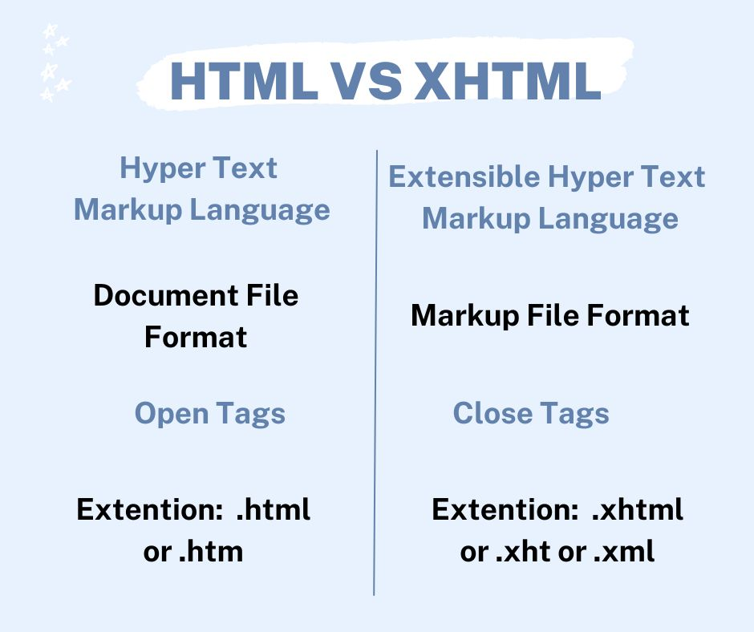

**Que.20 What are logical and physical tags in HTML?**

**Ans.** In HTML the formatting tags are divided into two categories: Physical tag: These tags are used to provide the visual appearance to the text. Logical tag: These tags are used to add some logical or semantic value to the text.

**Example.**

